Using the PRAW code, we ran the term statistics code and Latent Dirichlet allocation (LDA) model for the following subreddits: TeslaMotors,TeslaModel3, TeslaLounge, RealTesla, and electricvehicles. However, we decided to focus on TeslaLounge for this analysis due to a high coherence measure coupled with well-separated topics after running the LDA model.

After running the PRAW code for TeslaLounge and inputting the csv file into the term statistics code, we get the following results:

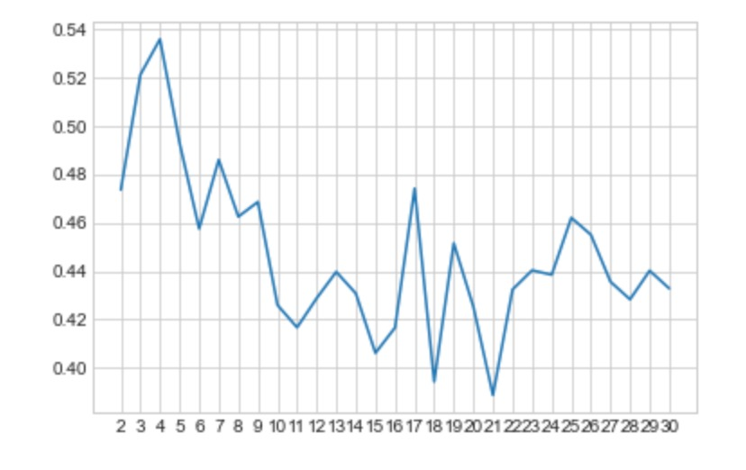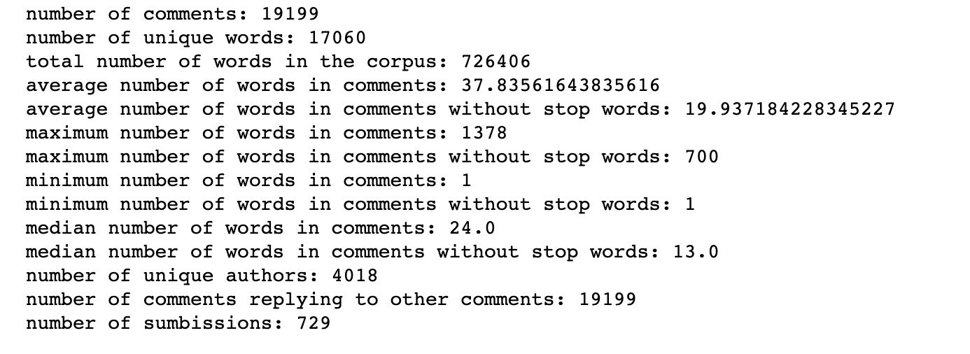

From the coherence measurement plot, we can see that 4 topics give us the highest score of around 5.35, indicating that separating the terms in the PRAW code into 4 topics is the most coherent. The higher the coherence score, the higher the degree of semantic similarity between high scoring words in each topic.

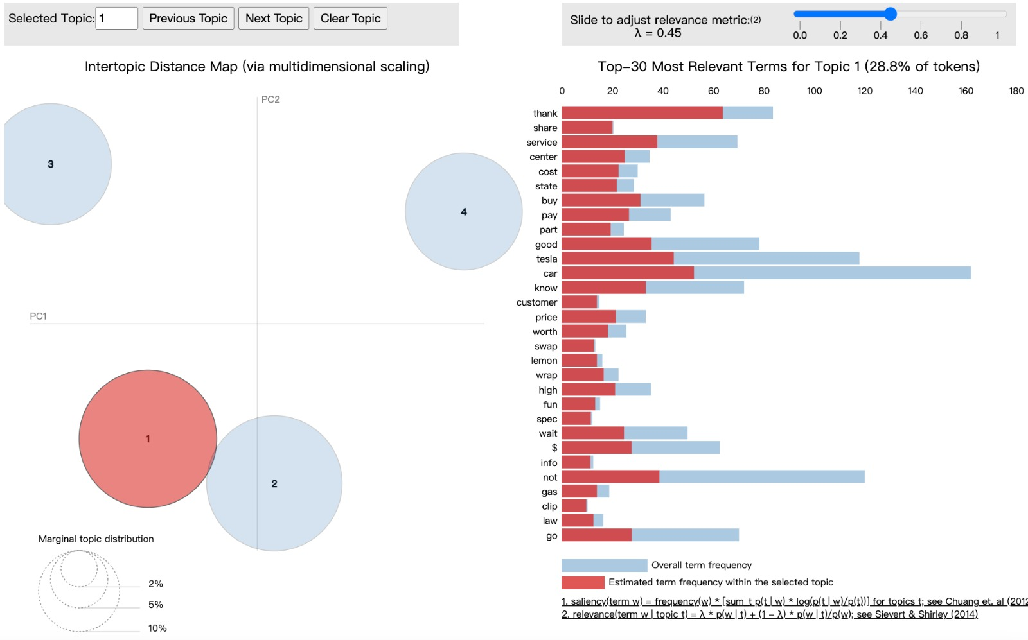

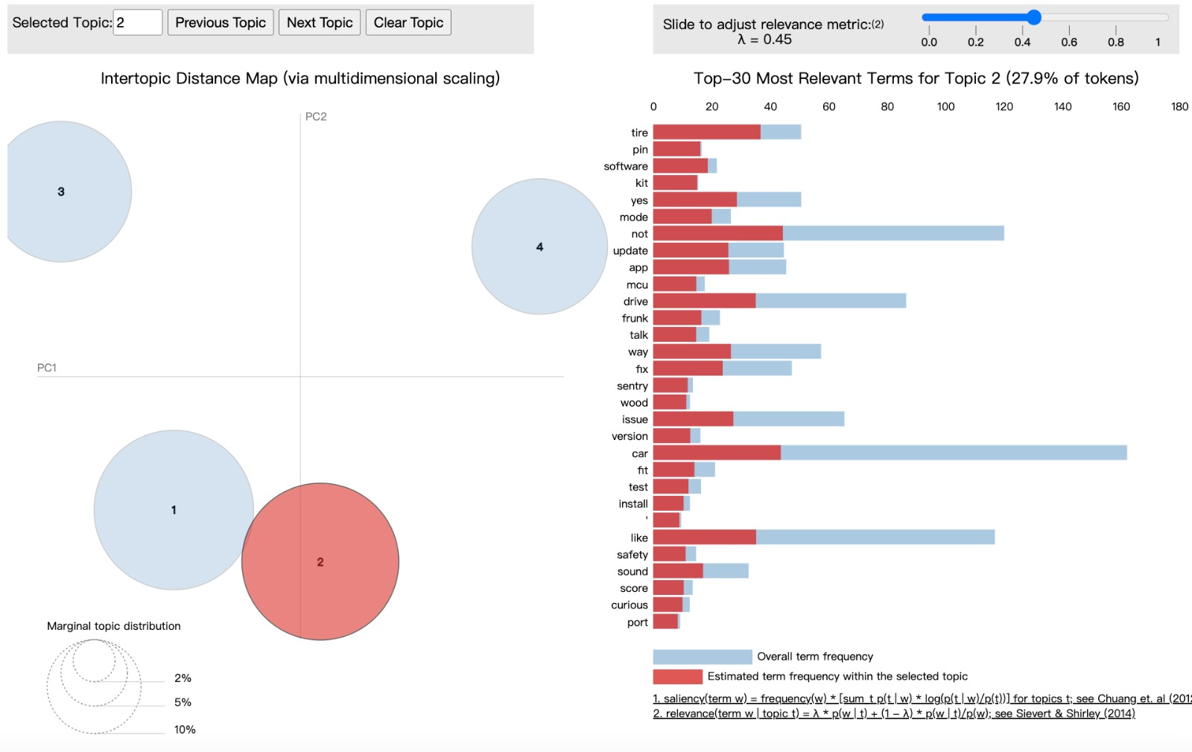

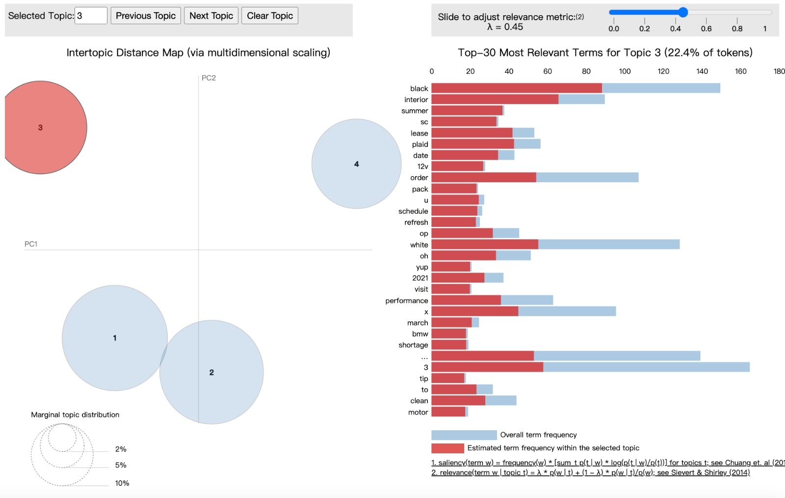

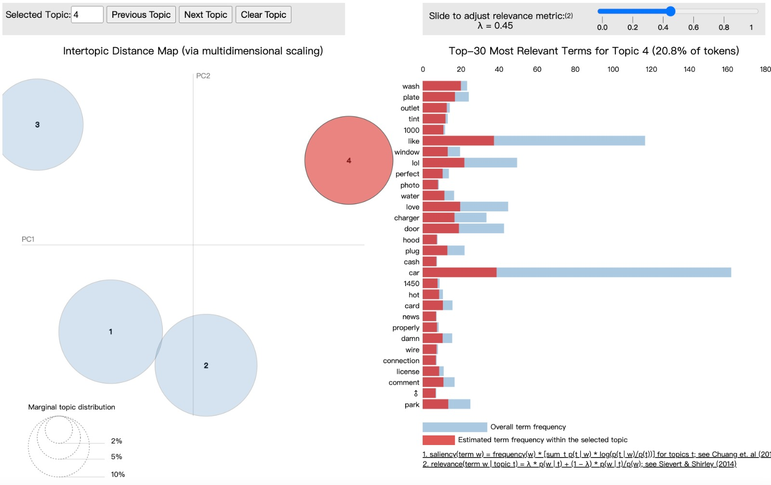

| Topic | Description | Relevant terms | Sample comments |
| --- | --- | --- | --- |
| 1 | Customer service, service centers, and how frequent Tesla customers need to service their vehicles | buy, service, center, car | 'Not only that theyâ€™re adding hundreds of thousands of new customers per quarter but itâ€™s unknown how much extra service capacity has gone up. My nearby service center has been pretty good regarding care but it still takes weeks for an appointment.' |
| - | - | - | 'Probably an axle shaft wearing out. Mine has similar issue and is in service for repair.' |
| 2 | Software and media related issues pertaining to Tesla and Tesla’s phone app | software, app, update, mcu, install | '>For control the phone from the cars touchscreen the Android TeslaMirror 2.0 will support this feature. Please wait.' |
| - | - | - | 'Yes I said thatâ€¦ every time AUTOpilot takes control the car enforces all of the AUTOmatic features so the software has the best chance of safe driving. All you have to do if this annoys you is add 1 extra step: tap AP stalk twice followed by a single tap on the left stalk. Now you never have to deal with Auto-brights ever again.' |
| 3 | Outer/inner appearance and aesthetics of a Tesla | Black, interior, white, summer | 'Is your blue with the chrome trim? Or the newer black trim? And what seats?' |
| - | - | - | 'Black magic marker is the cheap way or get them professionally fixed for like $125 or something' |
| 4 | Technical and casual maintenance of a Tesla | Wash, plate, outlet, window, | '2 winters. Looks great. No ppf and nothing special. I even take it to a tunnel car wash. Like others have said its a car and just enjoy driving it youâ€™ll feel better not worrying.' |
| - | - | - | 'Here is the main thing you need to consider. If you own a home get a wall charger or outlet installed. If you are in a place where you cant wouldnt recommend one.' |